PC^2 Web Team

Team Meeting 00/00

horizontal line

06March 2019 / 02:00 PM / Library

# ATTENDEES

Josie Isaacson, Andrew Combs, Dani Frodge, Ethan Holman

# PRIOR ACTION ITEMS

# NOTES

# ACTION ITEMS

# NEXT MEETING’S AGENDA

Next Meeting:

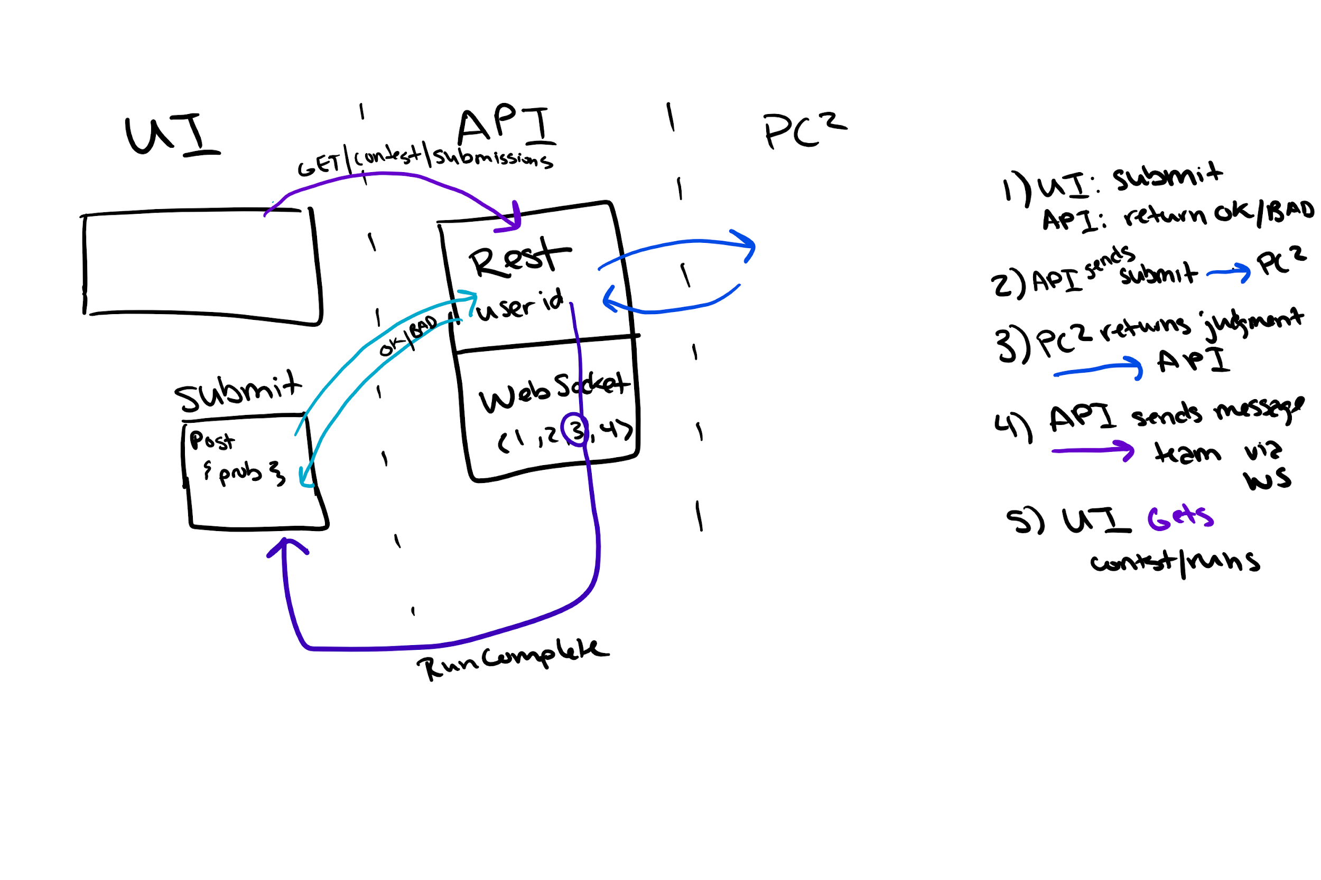

^From ¾ meeting